I used the guide on the top to decipher the number needed for the conversions and then did the math to find the binary number in decimal

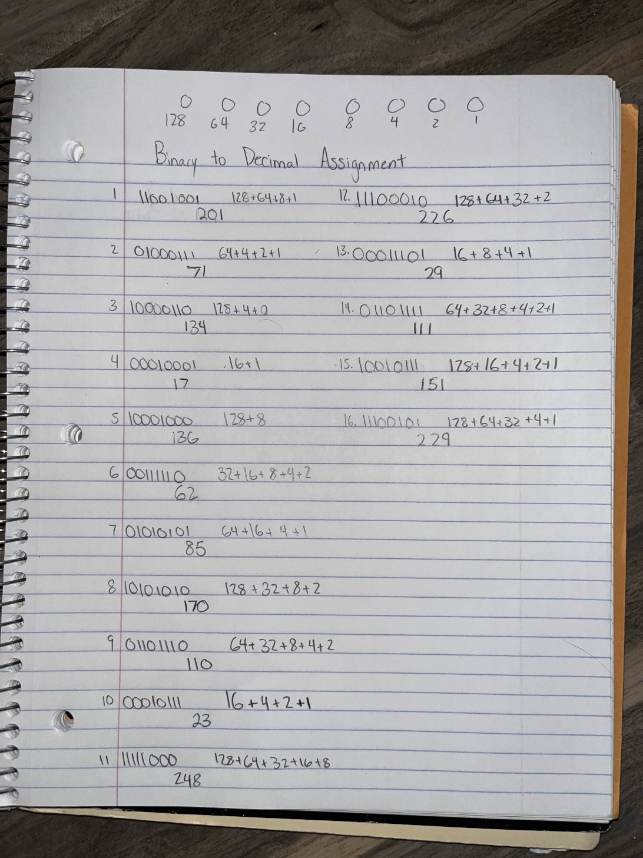Binary to Decimal
1 1 0 0 1 0 0 1 |  | 0 1 1 0 1 1 1 0
0 1 0 0 0 1 1 1 |  | 0 0 0 1 0 1 1 1
1 0 0 0 0 1 1 0 |  | 1 1 1 1 1 0 0 0
0 0 0 1 0 0 0 1 |  | 1 1 1 0 0 0 1 0
1 0 0 0 1 0 0 0 |  | 0 0 0 1 1 1 0 1
0 0 1 1 1 1 1 0 |  | 0 1 1 0 1 1 1 1
0 1 0 1 0 1 0 1 |  | 1 0 0 1 0 1 1 1
1 0 1 0 1 0 1 0 |  | 1 1 1 0 0 1 0 1
Computer Maintenance I: Numbering Systems Binary to Decimal Key
Copyright © Texas Education Agency, 2011. All rights reserved 7

